THIRD TERM E-LEARNING NOTE

SUBJECT: PHYSICS CLASS: SS2

SCHEME OF WORK

WEEK TOPICS
1. Reflection of light on plane surfaces, laws of reflection, image formation by plane mirror, application of reflection on plane mirror
2. Reflection on curved mirrors-types, images produced, uses and mirror formulae
3. Refraction of light, laws of refraction, effects of refraction, refraction through rectangular prism
4. Refraction through triangular prism, real and apparent depth, total internal reflection, application of total internal reflection
5. Refraction through lenses-types of lenses, image formation in lenses, lens formulae
6. Optical instrument-camera, projector, simple and compound microscope, telescope, human eye, defects and correction of vision
7. Dispersion of white light- production of pure and impure spectrum, colour of objects
8. Sound wave- production, transmission, speed, echo and its application, reverberation, characteristics of sound, forced vibration, resonance
9. Musical instruments
10. Vibration in pipes.

REFERENCE TEXTBOOKS
- New School Physics by M.W Anyakhoha
- New System Physics by Dr. Charles Chow.
- SSCE WAEC Past Questions
- UTME Physics Past Questions

WEEK ONE
- Reflection of light on plane surface
- Laws of reflection
- Image formation by plane mirror
- Application of reflection on plane mirror

REFLECTION OF LIGHT ON PLANE SURFACE
There are two types of reflection:
1. Regular Reflection
2. Diffuse Reflection or Irregular Reflection
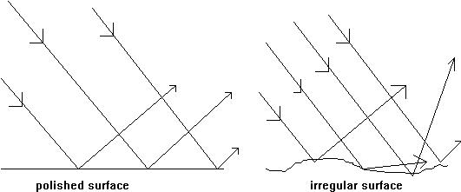

In regular reflection, parallel rays of light incident on a smooth or polished surface are reflected as parallel rays in one direction. In diffused or irregular reflection, parallel rays of light incident on a rough or irregular surface are reflected in various directions
LAWS OF REFLECTION
The first law of reflection states that the incident ray, the reflected ray and the normal at the point of incidence all lie in the same plane
The second law of reflection states that the angle of incidence (i) is equal to angle of reflection (r).

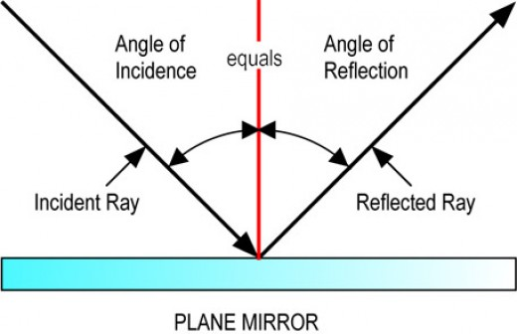

CHARACTERISTICS OF IMAGE FORMED BY PLANE MIRROR
1. It is the same size as the object
2. It is virtual
3. It is laterally inverted
4. It is upright
5. It is far behind the mirror as the object is in front of the mirror

IMAGE
There are two types of image:
1. Real image
2. Virtual image

A real image is one that can be caught on a screen. Light rays actually pass through real image. A virtual image is one that cannot be caught on a screen. It is one through which rays do not actually pass but which is nevertheless visible to the eye.

LATERAL INVERSION
The effect on plane mirror on objects placed in front of it whereby the appearance of the image looks like a reversal of the object is known as lateral inversion

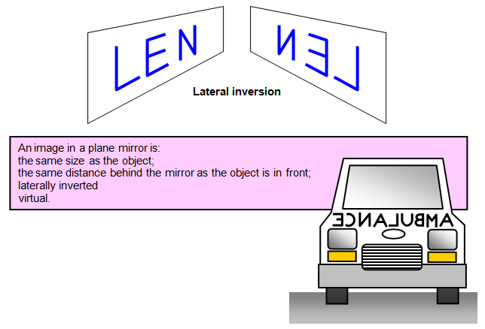

IMAGES FORMED BY INCLINED MIRROR
When two mirrors are placed at an angle to each other, the number of images formed is given by:
N = 360 - 1
Ө
N = Number of images
Ө = Angle of inclination
When Ө = 180⁰, the two mirrors will act as a single mirror and therefore formed only one image. When Ө = O, the two mirrors are parallel to each other and the image of object placed between them will be at infinity.

EFFECT OF MIRROR ROTATION ON REFLECTED RAY-MIRROR GALVANOMETER
If the direction of an incident ray on a mirror is kept constant and the mirror is rotated through twice that angle. This fact is utilized in mirror galvanometer (to measure very small electric current) and in the navigators sextant.

EXAMPLE
The reflection of a narrow beam of light incident normally on a plane mirror falls on a metre rule parallel to the mirror and at a distance of 1m. Calculate the angle of rotation of the mirror if the reflected beam is displaced 21.26cm along the metre-rule when the mirror rotated.
Angle ONP = 2 Ө
Tan 2 Ө = 21.26
100
= 0.2126
2 Ө = tan⁻¹ (0.2126)
2 Ө = 12⁰
Ө = 6⁰
EVALUATION
1. If the angle of reflection of a propagated ray is 35^{о}, calculate (a) The angle of deviation (b) The angle of glance (c) Angle of incidence.
2. An object is placed between two mirrors inclined at an angle 40 to each other. Find the number of images that will be formed.

USES OF PLANE MIRROR
1. It is used in periscope
2. It is used in kaleidoscope
3. It is used in sextant
PERISCOPE

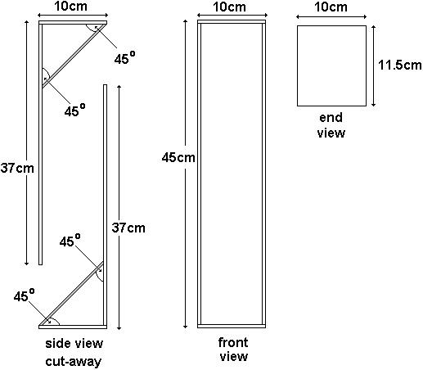

General Revision
- An object is released from rest at a height of 25m. Calculate the time it take to fall to the ground? [g=10m/s²]
2 A body is projected horizontally from the top of a tower with a velocity of 20m/s. It land on a level ground at a horizontal distance of 60m from the foot of the tower. Calculate the height of the tower. [g= 10m/s²]

WEEKEND ASSIGNMENT
1 Plane mirrors are used in all these except
- periscope (b) sextant (c) kaleidoscope (c) binoculars
2 Two plane mirrors are placed touching and at 60⁰ to each other. If an object is placed between the mirrors and viewed from above the mirrors. How many images will the eye see?
(a) 5 images (b) 6 images (c) 4 images (d) 3 images
3 When a ray of light is reflected from a plane surface, the angle of incidence is always equal to the angle of ( a) reflection (b) refraction ( c ) diffraction (d) dispersion
4 Which of the following statements is untrue?
When an image is formed in a plane mirror, the image formed will be
(a) the same size as the object(b) smaller than the object (c) laterally inverted (d) always virtual
5 In which of the following instrument is the image that is formed erect
- pin hole camera ( b) simple camera (c) microscope (d) periscope

THEORY
1 What do you understand by the term lateral inversion?
2 Two plane mirrors inclining at an unknown angle, forms 11 images. Find the value of the angle?

READING ASSIGNMENT
New school physics for senior sec schools pages 278-285
WEEK TWO
REFLECTION ON CURVED MIRROR-TYPES, IMAGE PRODUCED, USES AND MIRROR FORMULAE
TYPES OF CURVED MIRROR
When a shell of a hollow sphere of glass is made out of a piece of glass and then silvered, a curved or spherical mirror is obtained. These mirrors due to their curvature form images that are quite different from plane mirrors.

If the glass is silvered from outside so that light can be reflected from inside, it is called concave or converging mirror.
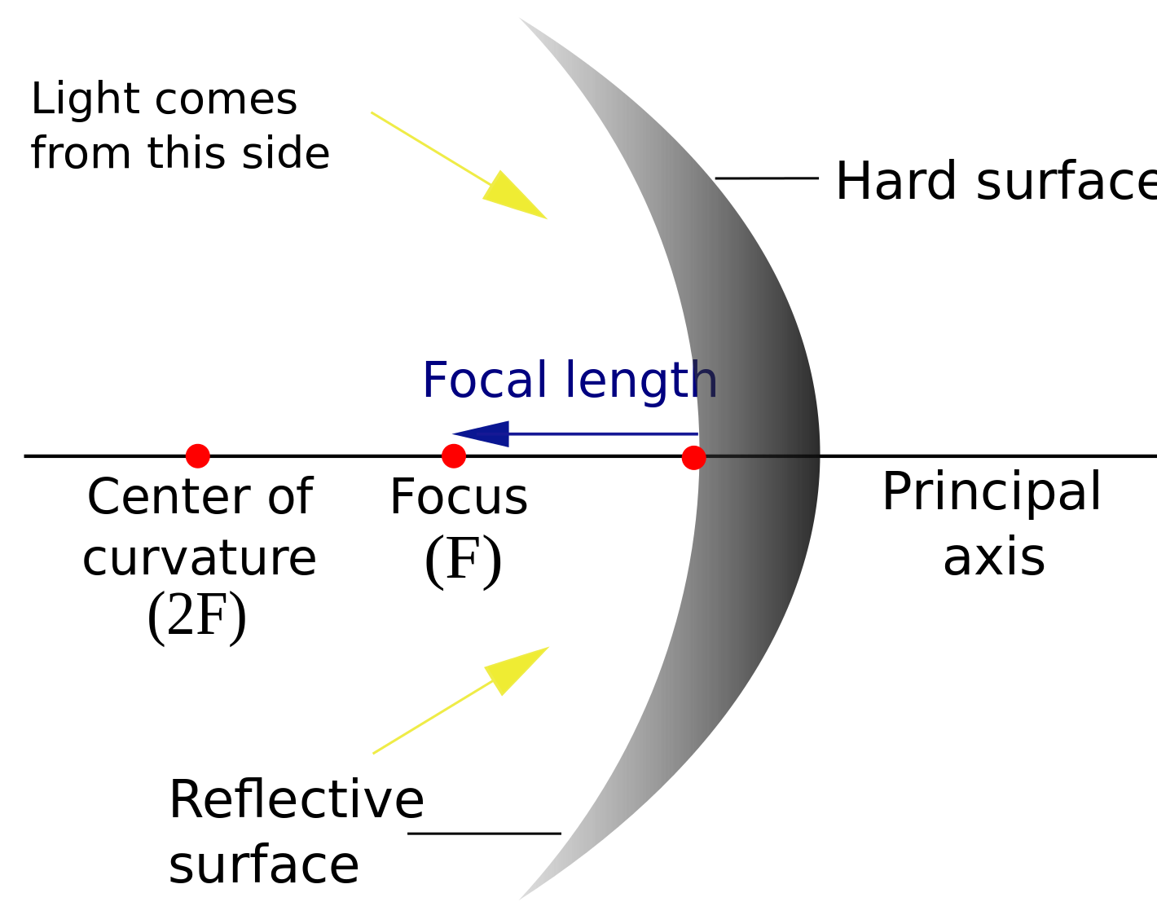

Convex mirror
If the coating is done so that the reflection is from outside, it is called convex or diverging mirror.
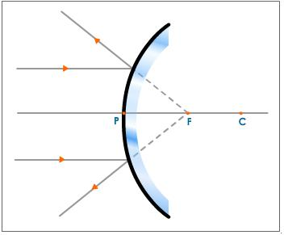

ESSENTIAL PARTS OF CURVED MIRROR
The essential parts of spherical mirrors are the aperture, the plow, the centre of curvature, the radius of curvature.

The aperture is the width (AB) of the mirror. The pole (P) is the centre of the reflecting surface of the curved mirror. The centre of curvature (c) is the centre of the sphere of which the mirror forms a part.

The radius of curvature is the distance from the pole to the centre of curvature (cp). It is the radius of curvature that determines the action of a curved mirror. For concave mirror, the radius of curvature is in front while it is behind for convex mirror.
The principal axis is the parallel line (pc) from the pole to the centre of curvature. When a beam of light is incident on a curved mirror, the rays are reflected or diverge from a point
called a focus.
The principal focus of a concave mirror is the point where rays that are parallel and close to the principal axis converge after reflection.
The principal focus of a convex mirror is the point from which rays parallel and close to the principal axis appear to diverge after reflection.
Hence, the focus of a concave mirror is real since the converging rays can be seen on the screen but of convex mirror is virtual. The focal length, f, of a spherical mirror is half of its radius of curvature.

r = 2f or f = r/2

r= radius of curvature f = focal length
FORMATION OF IMAGES BY SPHERICAL MIRROR
The position and nature of images formed by curved mirrors can be investigated by placing a brightly lit object and a screen in front of the mirror so that the light from the object is incident on the mid-point of the mirror.

RULES FOR CONSTRUCTING IMAGES FORMED BY SPHERICAL MIRROR

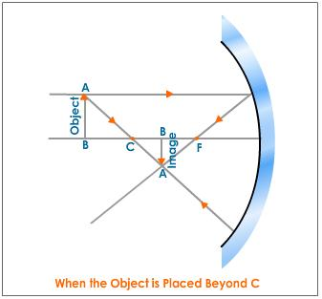

Rays diagrams can be constructed for images formed by spherical mirror based on the following rules:
- Rays parallel to the principal axis passes through the principal focus after reflection
- Rays through the principal focus are reflected parallel to the principal axis
- Rays passing the centre of curvature are reflected back along their path. This is in line with the principle of reversibility of light. Thus an object and its image can be interchanged. The two positions of the object and its image are called conjugate foci since an object placed at any of these positions will produce an image at the other.

IMAGES FORMED BY CONCAVE MIRROR
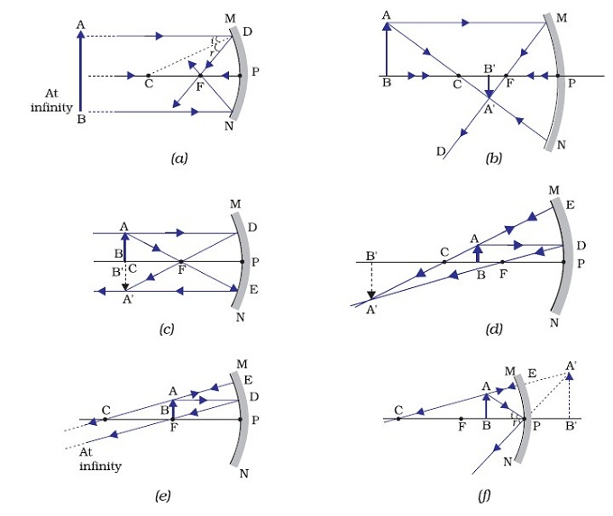
(a) OBJECT AT INFINITY
The image is
- At F
- Real
- Inverted
- Smaller than object
(1) OBJECT BETWEEN F AND P
- The image is behind the mirror
- Virtual
- Erect
- Larger than the object
(b) OBJECT BEYOND C
The image is
- Between C and F
- Real
- Inverted
- Smaller than object
(c) OBJECT AT C
The image is
- At c
- Real
- Inverted
- Same size as the object
(d) OBJECT BETWEEN F AND C
The image is
- Beyond C
- Real
- Inverted
- Larger than object
(e) OBJECT AT F
(1) the image is at infinity
IMAGE FORMED BY CONVEX MIRROR
Whatever the position of the object in a convex mirror, virtual images which are always erect and smaller than the object are formed.

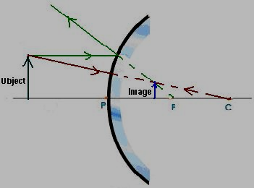

APPLICATION OF THE REFLECTION OF LIGHT
Concave mirrors are used in torches, as shaving mirror, in car headlamp and in reflecting telescope. Convex mirrors are used as driving mirrors because they give erect image and have a wide field of view than a plane mirror of the same diameter.

MIRROR FORMULAE
The image distance, V, the object distance, U, and the final length, f, of a mirror or lens is related by
1 + 1 = 1
V U F
When 1/U is plotted against 1/V, the intercept on either axes is equal to 1/F, from which the focal length can be calculated. The focal length is equal to the slope of the graph of UV against U + V.

MAGNIFICATION
The linear or transverse magnification of a mirror is the number of times the image is bigger than the object.
M = image height
Object height

M = image distance
object distance

EXAMPLE
An object is placed 30cm from a concave mirror focal length 15cm. Find the magnification of the image produced.
U = 30cm
F = 15cm
V = ?
1 + 1 = 1
V U F
1/15 = 1/30 + 1/v
1/15 – 1/30 = 1/V
2 – 1 = 1/v
30
1/30 = 1/V
V = 30cm
But m = v/u
= 30/30 = 1
(2) Find the expression for linear magnification produced by a concave mirror of radius of curvature, r, if u and v are the object and image distances respectively.
1 + 1 = 1
V U F
F = r/2
1 + 1 = 2
U V r
Multiply throughout V,
V + V = 2V
U V 2r
M = 2v – 1
R

USES OF CURVED MIRROR
Concave mirrors are used as shaving mirror, as reflectors in reflecting telescopes and microscope

EVALUATION
1. A concave mirror of radius of curvature 20cm produced an inverted image 3 times the size of an object placed on and perpendicular to the axis, calculate the position of the object and image.
2. A concave mirror of radius of curvature 20cm has a pin placed at 15cm from the pole. What will be the magnification of the image formed?

General Evaluation:
1. A body is projected from the ground at an angle of θ to the horizontal with a velocity of 30m/s. It reaches a maximum height of 11.25m, calculate
a. The value of θ
b. the time taken to strike the ground
c. the range
d. its velocity 2sec after projection [g= 10m/s²]
2. A ray of light is incident on a plane mirror at an angle of 35^{о}. What is the angle made by the reflected ray with the surface of the mirror?
WEEKEND ASSIGNMENT
- The image obtain on the screen of a pin-hole camera becomes less sharply defined when the (a) object is moved further from pin-hole (b) screen is moved further from the screen hole (c) object is made smaller (d) pin-hole is made larger
2. An object 3.0m high is placed at 7.5m from a pin-hole camera. If the image is 6.0cm. What
is the distance of the film from the pin hole (a) 3.75cm (b) 7.50cm (c) 15cm (d) 30.0cm
- If the size of the hole of a pin-hole camera is increased the image formed becomes
(a) brighter and blurred (b)brighter and larger (c)brighter and sharper (d)blurred and larger
- A body that produces its own light is said to be (a) luminous (b)non- incandescent (c) opaque (d) translucent
5 A man at the back of a crowd watches a parade by holding a plane mirror just above his head the parade passes 6m behind his head and the mirror is 0.25m in front of the man how far does the image in the mirror appear to be from the man?
(a) 6.50m (b) 6. 25m (c) 6.00m (d)5.75m
Theory
Draw the position and nature of the image produced by an object placed at the following points on the concave mirror
1 Between F and P
2 At F
3 At C
4 Between F and C
5 Beyond C
6 At infinity

READING ASSIGNMENT
New school physics for senior sec pages 288-293

WEEK THREE
REFRACTION OF LIGHT
- Laws of refraction,
- Effects of refraction,
- Refraction through rectangular prism.

REFRACTION
There is a change in the direction and speed of a ray of light when it passes from medium to another medium of different density. This change in the direction of the light of the light ray which is due to difference in the speed of light in different media is called refraction.
When a ray of light travels from optically less dense medium (air) to an optically dense medium (water, glass), it bends towards the normal.
A ray passing from glass or water to air is bent away from the normal
When a wave, e.g light wave is refracted,
- Its direction of travel changes
- Its velocity changes.
- Its wavelength changes
- Its frequency remains the same.

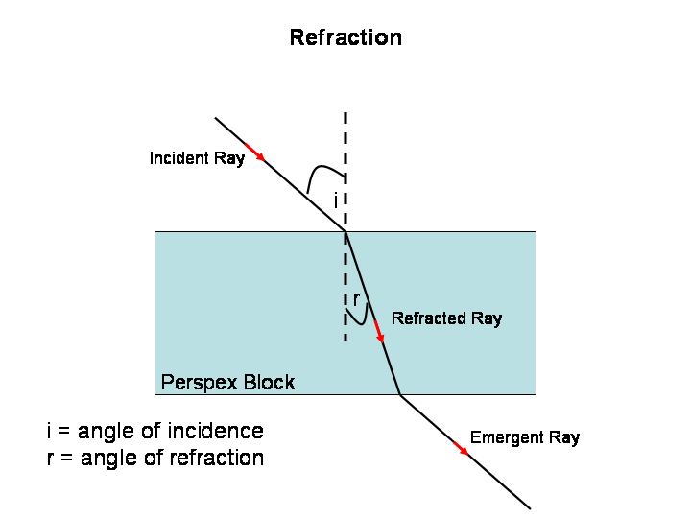

REFRACTION THROUGH RECTANGULAR PRISM
LAWS OF REFRACTION
1. The incident and refracted ray are in opposite sides of the normal at the point of incidence, all the three are in the same plane.
2. The ratio of the sine of the angle of incidence to the sine of the angle of refraction is a constant for a given pair of media.
The second law is known as Snell’s law

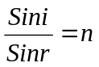
The constant n, is known as the refractive index of the second medium with respect to the first medium. It is a number which gives a measure of refraction or bending of light as it travels from one medium to another.
ang =
Sine of angle of incidence in air
Sine of angle of refraction in glass

gna =
Sine of angle of incidence in glass
Sine of angle of refraction in air

From the principle of reversibility of light
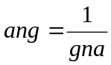
Furthermore speed of light in glass
ang =
Speed of light in air

EFFECTS OF REFRACTION
The phenomenon of refraction is responsible for the following
1 The bottom of a clear river or pond appears shallower than it really is
2 A rod or spoon appears bent or broken when it is partially immersed in water or any liquid
3 Letters in print seem to be nearer when we place a thick block of glass over them.

General Revision
- The magnitude of the resultant of two mutually perpendicular forces F₁ and F₂ is 13N. If the magnitude of F₁ is 5N what is the magnitude of F₂? (a)16.0N (b) 12.0N

- Two 10N forces are inclined at an angle of 30⁰ to each other the magnitude of the resultant force is?

Reading Assignment: New School Physics Pages 290 - 292

WEEKEND ASSIGNMENT
1 The direction of a light ray changes as it passes from one medium to another. This phenomenon is called A diffraction B reflection C dispersion D refraction
2 The velocities of light in air and glass are 3.0 x10⁸ m/s and 1.8 x10⁸ m/s respectively. Calculate the sine of the angle of incidence that will produce an angle of refraction of 30⁰ for a ray of light incident on glass A. 1.2 B. 1.0 C . 0.8 D. 0.6
3 A transparent rectangular block 5.0 cm thick is placed on a black dot. The dot when viewed from above is seen 3.0 cm from the top of the block. Calculate the refractive index of the material of the block A. 2/5 B. 3/5 C. 3/2 D. 5/3 E. 5/2
4 When a ray of sunlight passes obliquely through a rectangular glass block
A. it emerges without displacement parallel to the incident ray
B. it gets dispersed into seven visible colours without any deviation at all
C. it deviates without dispersion
D. it gets laterally displaced and the emergent ray is parallel to the incident ray
5 The absolute refractive indexes of glass and water are 3/2 and 4/3 respectively. The refractive at the interface when a ray travels from water to glass is A ½ B 8/9 C 9/8 D17/12

THEORY
1 A ray of light passes from air through a rectangular block of glass with parallel side 4.5 cm apart at an angle of incidence of 52⁰,find
(a) The lateral displacement of the ray (b) The angle of refraction (Refractive index of glass=1.5)
2 Radio wave travels on air at 3.0X10⁸m/s. if the waves enter water of refractive index of 4/3 , calculate the speed of the radio waves in water.

WEEK FOUR
- Refraction through triangular prism,
- Real and apparent depth,
- Total internal reflection and its application

Refraction Through Triangular Prism
When a ray of light passes through a triangular prism, it is refracted as shown below
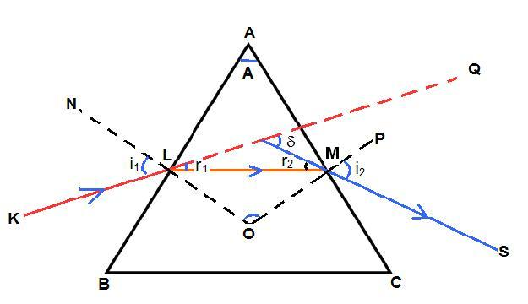
The angle between the incident ray and the emergent ray is known as the angle of deviation. The angle of deviation decreases as the angle of incidence increases

The refractive index, n=sin(A/2+D/2)/sinA/2

TOTAL INTERNAL REFLECTION

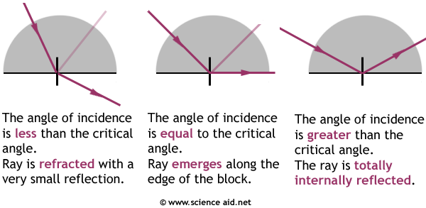

When light passes at a small angle of incidence from a denser to a less dense medium e.g. from glass to air, there is a strong refracted ray. There is also a weak ray reflected back into the denser medium.
When the angle of incidence increases, the angle of refraction also increases. At a certain increase of the angle of incidence, the angle of refraction is 90⁰. This angle of incidence in the denser medium for which the angle of refraction in the less dense medium is 90⁰, is referred to as the critical angle ( c). For angle of incidence greater than C, the refracted ray disappears and all the incident light is reflected back into the denser medium. At this point, the ray is said to experience total internal reflection. Example of total internal reflection is the mirage on the road, where the refractive density of warm air is less than that of cool air and light meets a layer at a critical angle, it suffers total internal reflection.

REAL AND APPARENT DEPTH
A thick slab of glass appears to be only two –third of its real thickness when viewed vertically from above. Similarly, water in a pond appears to be only three quarters of its real depth. Rays from a coin at the bottom of a bucket of water are refracted away when they leave water and enter the eyes. They appear as if coming from a virtual image, which is apparent depth while the actual depth of the bottom remains and is referred to as real depth
Refractive index=real depth/apparent depth

General Revision
- Distinguish between the resultant and equilibrant forces.
- Give two (02) ways to increase the stability of a body.
WEEKEND ASSIGNMENT
- The direction of a light ray changes as it passes from one medium to another. This phenomenon is called A diffraction B reflection C dispersion D refraction
- The velocities of light in air and glass are 3.0 x10⁸ m/s and 1.8 x10⁸ m/s respectively. Calculate the sine of the angle of incidence that will produce an angle of refraction of 30⁰ for a ray of light incident on glass A 1.2 B 1.0 C 0.8 D 0.6
- A transparent rectangular block 5.0 cm thick is placed on a black dot. The dot when viewed from above is seen 3.0 cm from the top of the block. Calculate the refractive index of the material of the block A 2/5 B 3/5 C 3/2 D 5/3 E 5/2
- When a ray of sunlight passes obliquely through a rectangular glass block
Ait emerges without displacement parallel to the incident ray
B it gets dispersed into seven visible colours without any deviation at all
C it deviates without dispersion
D it gets laterally displaced and the emergent ray is parallel to the incident ray
- The absolute refractive indexes of glass and water are 3/2 and 4/3 respectively. The refractive at the interface when a ray travels from water to glass is
(A) ½ (B) 8/9 (C) 9/8 (D)17/12

THEORY
- A ray of light passes from air through a rectangular block of glass with parallel side 4.5 cm apart at an angle of incidence of 52⁰,find A The lateral displacement of the ray B The angle of refraction (Refractive index of glass=1.5)
- The critical angle for a transparent is 39. Calculate the refractive index of the substance.

Reading Assignment: New school physics for senior secondary school pages 266-270

WEEK FIVE
Refraction through lenses
- Types of lenses
- Image formation in lenses
- Lens formulae

LENSES:
Lenses are used as magnifying glasses. They are also used in microscopes, telescopes, cameras and projectors. The human eye has a natural lens and which enables people to see clearly. There are two types of lenses: Converging and Diverging lenses.

The converging lens brings light rays together while the diverging lens spreads light rays apart. A converging (convex) lens bulges at the centre while diverging lens gets thinner at the centre.

TERMS
Terms which are commonly used in lenses include, principal axis of a lens, the principal focus of a lens, optical centre of a lens, and focal length of a lens. The principal axis of a lens is the line joining the centre of curvature of the two surfaces of the lens, and passing through the middle of the lens.

The principal axis of a lens is the line joining the centre of curvature of the two surfaces of the lens, and passing through the middle of the lens.

The principal focus of a lens is the point on the principal axis to which all rays parallel and close to the axis converge or diverge, after refraction the lens. The principal focus of a converging lens is real, while that of a diverging lens is virtual. The optical centre of lens is defined as the centre of the lens which is a point on the principal axis of the lens. Rays of light which pass through the optical centre are undeviated. The focal length of a lens is the distance between the optical centre and the principal focus of the lens.
FORMATION OF IMAGES IN LENSES
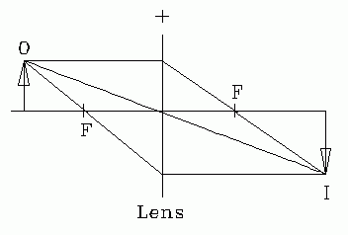
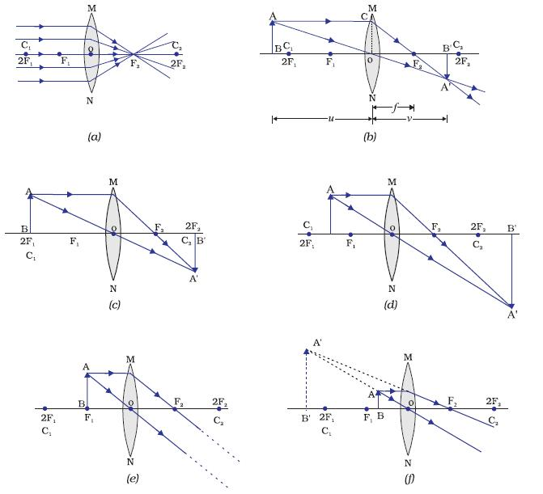
COVERGING LENS
To produce the image of an object by a converging lens, two major rays are required:
(1) A ray from the top of the object incident on the middle, c, of the lens and passes through the lens undeviated.
(2) A ray from the top of the object parallel to the principal axis, incident on the lens, and refracted through the principal focus, F. At the point where these two rays interact, the image of the object is formed.

OBJECT AT INFINITY
When an object is very far from the lens i.e at infinity, the image is real, inverted and formed at the focus of the object beyond 2f1.

OBJECT BEYOND 2F1
When an object is very far from the les i.e at infinity, the image is real, inverted and formed at the focus of the object beyond 2f1.

OBJECT BEYOND 2F1
When an object is placed beyond 2F1, the image of the object is formed between F and 2F and is real, inverted and smaller than the object (diminished).

POWER OF A LENS
The power of a lens is the reciprocal of the focal length of a lens in metres.
P = 1/f

THE SIMPLE MICROSCOPE OR MAGNIFYING GLASS
A complex lens gives an enlarged upright virtual image of an object placed inside the principal focus. This constitutes a simple microscope. It is used for reading and studying biological specimens.

General revision
- A uniform meter rule 0f mass 90g is pivoted at the 40cm mark. If the rule is at equilibrium with an unknown mass m, placed the 10cm mark and a 72g mass at the 70cm mark determine m.
- A wire is gradually stretched until it snaps .Sketch a load – extension graph for the wire and on the graph indicate the (a)Elastic limit (b) Yield point (c) Maximum load (d) Breaking point

Weekend Assignment
- The reciprocal of a lens is called …………….
- Principal axis (b) power (c ) bi-convex (d) optical centre
- ………….. is the distance between optical centre and the principal focus of a lens
- Optical centre (b) focal length (c ) principal axis (d) radius of curvature
- An object placed 36cm from a converging lens of a focal length 24cm, forms a real image which is 6cm high. What is the height of the object.
- 4cm (b) 3cm (c) 2cm (d) 12cm
- An object is placed 20cm from a converging lens. If the real image formed is 80cm. find the focal length of the lens?
- 15cm (b) 30cm (c) 10cm (d) 16cm
5. A candle of height 5cm is placed 30cm from a convex lens of vocal length 10cm. The height of the candle’s image is
(a) 10cm (b) 7.5cm (c) 5cm (d) 2.5cm

THEORY
- The screen of a pinhole camera is a square of side 0.16m and it is 0.15m behind the pin hole. The camera is placed 11m from a flag staff and positioned so that the image of the flag staff is formed centrally on the screen. The image occupies three quarters of the height of the screen. What is the height of the flag staff.
- A converging lens of focal length 15cm forms a virtual image at a point 10cm from the lens. Calculate the distance of the object from the lens

READING ASSIGNMENT
New School Physics pg 273 - 285

WEEK SIX
OPTICAL INSTRUMENT
THE COMPOUND MICROSCOPE
The compound microscope produces a greater magnification than the simple microscope. It has two lenses, the objective lens which has a short focal length and the eye piece used as the magnifying glass to view an image formed by the objective lens.
The image formed by the objective lens is within the principal focus of the piece. So a final image is formed at the least distance of distinctive vision from the eye.

THE ASTRONOMICAL TELESCOPE
An astronomical telescope is used for viewing distance objects like stars and planets. The astronomical telescope uses two convex lenses; the objective lens and the eye piece.
The objective lens has a long focal length and forms a real image of a distant object at its focal plane. The position of the eyepiece and the objective lens must coincide along the principal focus so that the final image is at infinity. The astronomical telescope gives an inverted image which can be tolerated when looking at the stars but is at a disadvantage on the earth.

THE HUMAN EYE
The optical system of the eye consist of the cornea, the aqueous, the vitreous humour and the lens. They form a real and inverted image of an external object on the retina. The retina transmits the impression created on it by the image through the optic nerve to the brain. The brain then interpretes the impression. The amount of light entering the eye through the pupil is regulated by the iris.)

- LONG SIGHT (HYPERMETROPIA)
A long sighted person can see objects at a distance but cannot see close objects clearly. His near point is more than 25cm which is the near point of the normal eye. It is caused by the eye ball being too short so that rays from object at 25cm from the eye are brought to focus behind the retina. It is corrected by converging lens placed in front of the eye for near vision.

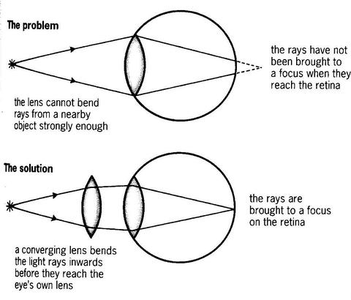

(b) SHORT SIGHT (MYOPIA)
A short sighted person cannot see distant objects clearly as rays from such objects are focused in front of the retina. His far point is less than the normal far point which is at infinity. It is corrected by the use of diverging lens. The diverging lens makes the object at infinity to appear to be at the person's far point.

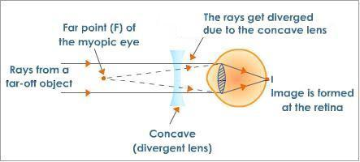

General revision
- A ball of mass 100g travelling with a velocity of 100m/s collides with another ball of mass 400g moving at 50m/s in the same direction. If they stick together what would be their common velocity?
- An N.N.P.C gas cylinder containing 15Kg of gas was left open and the gas emptied 3. 8minutes at an average speed of 20m/s what force was exerted on the gas in the cylinder.

Reading Assignment
New School Physics Pages 319 - 322

Weekend Assignment
- For correcting long sight defects in the human eyes, we require ………..
- Converging lens (b) diverging lens (c) microscope (d) periscope.
- Which of the following optical instruments does not make use of a lens?
(a) projector (b)periscope (c ) eye (d) microscope.
- The ability of the eye to focus object at different distances is called ……..
- Power (b) accommodations (c) normal vision (d) long sight
- Binocular vision
- Restricts the field of view (b) Enables a person to see further
(c ) Enables objects to be seen in relief (d)Enables objects to be seen clearly.
- ………. Waves are set up in pipes
- Stationary (b) longitudinal (c) transverse (d) electromagnetic.

THEORY
- State three types of eye defect and the types of lenses for correction.
- State three types of optical instruments.

WEEK SEVEN
- Dispersion of white light
- production of pure and impure spectrum
White light has a band of wavelengths of different colours. This is called the spectrum colours. Red light has the longest wavelength in air (700 x 10-9m) while violet light has the shortest wavelength (450 x 10-9m) in air.

In a vacuum and in air, all the colours of white light travel at the same speed. But in glass, the colours travel at different speeds.Thus, a glass prism can separate or dispute white light into its various colours or wavelengths.

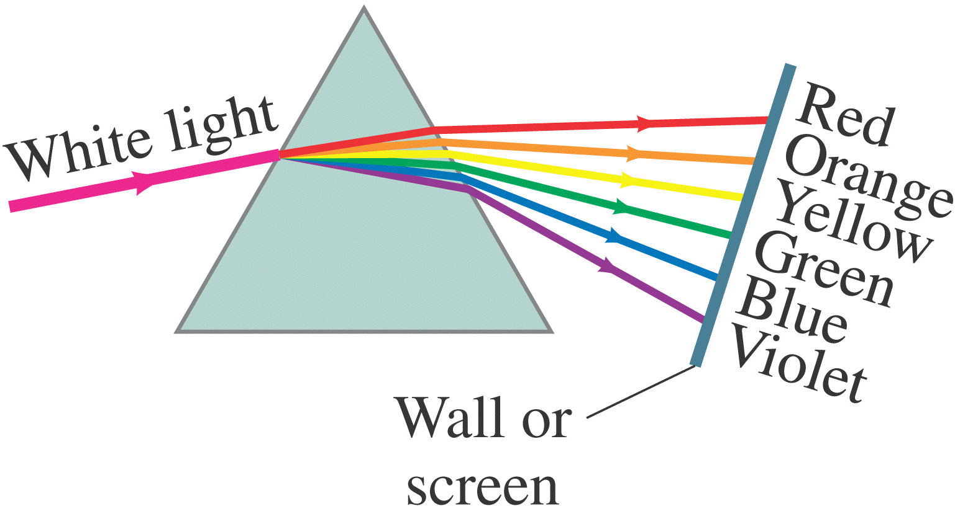

White light from a source e.g sunlight, passes through a narrow slit and is incident on the glass prism. After leaving the glass prism, white light is separated into a band or spread of impulse colours which are formed on the screen. The spectrum of white light consists of (bands of) red, orange, yellow, green, blue, indigo and violet colours (ROYGBIV). The separation of the colours by the glass prism is called dispersion. The red colour is deviated least, while the violet colour is deviated most.

Production of a pure spectrum
The spectrum described above is an impure spectrum, because the different bands of colour overlap. A spectrum in which such an overlap does not occur is called a pure spectrum. This can be obtained by using an arrangement of converging lenses in addition to the glass prism.

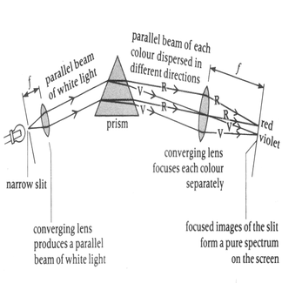

White light from a source passes through a narrow slit and are incident on the first converging lens. The slit is located at the focus of the lens, and hence the white light is rendered parallel after refraction through the lens. Thus, a beam of parallel light is incident on the glass prism. In this way, rays of the same colour will suffer the same amount of deviation by the prism, and each colour will emerge as a parallel beam. They are then brought to focus by the second converging lens. The different colours, red, orange, yellow, green, blue, indigo and violet are then brought to different foci on the screen.

COLOUR MIXING
Each colour of light has its own characteristic wavelength. If the light if the yellow wavelength enters the eye, it sees yellow. However, if a mixture of red and green light enters the eye it also sees yellow. All the colours that the eye sees can be made by mixing three basic colours, these three colours, which are called primary colours, are red, blue and green.
The colour made by mixing any two primary colours are called secondary colours. These are:
(i) red + blue = magenta
(ii) blue + green = cyan
(iii) green + red = yellow
The mixing of coloured lights is known as additive mixing. All the three primary colours mix together to give white light.
Red + blue + green = white
The operation of colour movies is based on addictive colour mixing.
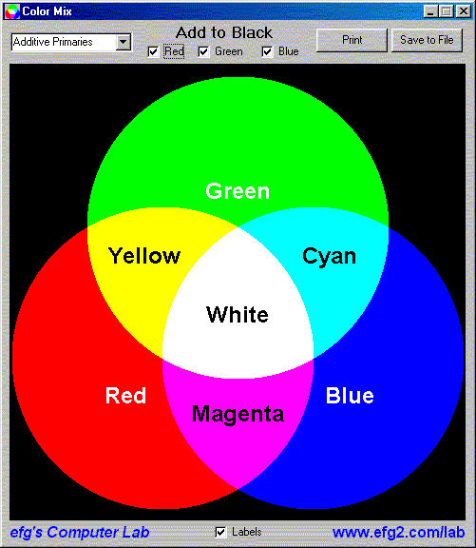

COLOURED FILTERS
Coloured filters are made out of coloured glass. A coloured filter transmits its own colour, but absorbs any other colour which falls on it.

COLOURED PIGMENT
An object can only be seen when light is reflected from it into the eye. The substance which gives an object its colour is called a pigment. A pigment absorbs all colours except its own, which it reflects.

A black pigment absorbs all colours and reflects none. A white pigment reflects all colours. Coloured objects such as pigments (paints) used by painters can also be mixed together. The mixing of colours pigments is known as subtractive mixing.

General Revison
- Displacement of a particle executing SHM is given by x = 0.01 sin (100 πt + 0.05). Its time period is ..............
- A force of 6.4 N stretches a vertical spring by 0.1 m. The mass that must be suspended from the spring so that it oscillates with a period of 4πs is..................

Weekend Assignment
1. The separation of white light into its constituent colour is known as
(a) deviation (b)defraction (c) dispersion (d) deflection
2. The light of one wavelength or colour is called
(a) yellow light (b) green light (c) monochromatic light (d) blue light
3. The colours obtained by mixing any two primary colours are called ……..
(a) primary colours (b) secondary colours (c) indigo (d) violet
4. In a pure spectrum, what is the function of the lens near the length source?
(a) to separate the light colours (b) to produce parallel rays (c) to diverge the light rays (d )to produce dispersion necessary for the spectrum
5. The following colours are primary colours except? (a )Red (b) Green (c)Blue (d) Yellow

Theory
- Explain the term ‘dispersion’
- Describe with the aid of a well labeled diagram how a pure spectrum of white light can be produced?

Reading Assignment
New School physics for senior secondary schools pages 301 - 305

WEEK EIGHT
SOUND WAVES
PRODUCTION
Sound waves are produced by vibrating objects. Some of the source of sound are talking, shouting, beating, beating drums, blowing of flutes, shooting of a rifle, a ringing telephone, the noise from moving cars and airplanes and musical instruments.

TRANSMISSION OF SOUND WAVES
Sound travels from place to place as sound waves. Sound must have a substance to travel through i.e it does not travel through a vacuum. There is nothing in a vacuum to pass on a vibrations. Sound waves are longitudinal waves i.e the air vibrates backwards and forwards in the wave is moving.

It can travel through solids, liquids and gases. The air changes the vibration into impulses which are carried into brain for interpretation.

CHARACTERISTICS OF SOUND
A. PITCH
This depends on the frequency of the sound waves. If the frequency is increase, the pitch of the sound also increases.

B. LOUDNESS
The loudness of the sound depends on its intensity. The intensity of the sound of the wave is the rate of the flow of energy per unit area, perpendicular to the direction of the wave.
Intensity is proportional to the square of the amplitude. The greater the intensity, the louder the sound.

C. QUALITY
This is the property which enables us to distinguish the same note played on different instruments e.g a piano and an organ, the quality of a musical notes depends on the harmonies. When a note is produced, the strongest, audible frequency heard is the fundamental. All other frequencies present ar harmonics or overtones.

FORCED VIBRATION
If tuning fork A is struck and stopped, you find that it will cause tuning fork B to vibrate, provided both forks have the same frequency. This is called forced vibration. Other form off forced vibration include:

(1) RESONANCE
Resonance is a special case of forced vibration which occurs when a system is made to vibrate at its own natural frequency as a result of forced vibrations received from another sources of the same frequency.

(11) RESONANCE IN STRINGS
stationary waves can occur on a stretched string or wire.. This is obtained by varying the driving frequency of the string.

General revision
- A machine of velocity ratio 5 is used to raise a load with an effort of 500N if the machine is 80% efficient determine the magnitude of the load
- A machine of efficiency 80% is used to raise a body of mass 75Kg through a vertical height of 3m in 30s. Calculate the power output

Weekend Assignment
- Sound wave differs from water wave………
(a)energy transfer is involve (b) they can be refracted and reflected
(c )no transfer of the medium is involved (d)They are longitudinal wave.
2. A source of sound produces waves in air if wavelength 1.65m. if the speed of sound in air is 330m/s, the period of vibration is.
(a) 200 (b) 0.005 (c ) 0.5 (D) 0.02
3. The speed of sound traveling in various media increases in the following correct order.
(a) Iron bar, air, water (b) air, iron bar, water (c) air, water, iron bar (d) water, iron bar, air.
4. Why does the sound from an enclosed bell jar gradually fade away as the jar is gradually evacuated? (a) the sound is forced out (b) the pressure within the jar is reduced (c) there
is no more material medium (d) the temperature is reduced.
5. A noise of frequency 2000Hz has a velocity of 400m/s. What is the wavelength of the noise? (a) 0.02m (b) 0.25m ( c ) 0.2m (d) 2m

Theory
- Define a musical note
- Mention the three characteristics of sound and the factors on which they depend

Reading Assignment
New School Physics, pgs. 332-341

WEEK NINE
MUSICAL INSTRUMENTS
(A) WIND INSTRUMENTS
Clarinets, flute, saxophone, trumpet are examples of wind musical instruments. A musical note originates from a source vibrating in a uniform manner with on or more constant frequencies music is a combination of musical notes. All wind instrument use resonating air columns to produce their sounds. Sounds from wind instruments may originate from (1) Air vibrating over an opening e.g. organ and flute.
(2) The vibrating lips of a brass instrument e.g. trumpet.
(3) A vibrating heel e.g. clarinet, saxophone.
Some columns are of fixed length, their resonant frequencies being altered by the opening or the closing of holes in the column e.g. clarinet, a recorder, some instruments are played by altering the length the air column e.g. a trumpet.

(B)STRINGED INSTRUMENTS
The guitar, the sonometer and piano are examples of stringed musical instruments. These instruments may be set in vibration by a bow, or plucked with a finger e.g. a violin is bowed while a guitar is plucked. The frequency of a vibrating string depends on its length, the mass and the force that keeps the string taut. Stringed instruments vibrate as a whole and in loops at the same time e.g. the violin. These vibrations produce both the fundamental and overtones frequencies.

(C) PERCUSSION INSTRUMENTS (drums, bell, talking drum)
Percussion instruments produce musical notes when they are struck or hit. They have rods, plates or membranes that vibrate when struck; for example, there are rods in bells, plates (bars) in xylophones and membrane in drums.

ECHOES AND THEIR APPLICATION
An echo is the repetition of sounds caused by the reflection of sound waves from a hard surface. Such as buildings, walls and cliffs are good reflector of sound.
Echoes have practical importance in the development of sonar, speed traps, prospecting for oil and determining the speed of sound. In the determination of speed of sound by echo, we use the expression

2x = V t

Where
V = velocity of sound x = distance between the source of sound and reflecting surface
t = total time taken

EVALUATION
1. What are beats?
2. State three applications of echo

General Revision
1. A boat is rocked by waves of speed 30m/s whose successive crests are 10m apart. Calculate the rate at which the boat receives the waves.
2. A body is projected horizontally from the top of a cliff 45m above the ground. If the body lands at a distance 30m from the foot of the cliff, calculate the speed of the projection. ( g = 10m/s² )

Reading Assignment
New School Physics Pgs 342 - 347

Weekend Assignment
1. Sound wave differs from water wave………
(a)energy transfer is involve (b) they can be refracted and reflected
(c )no transfer of the medium is involved (d)They are longitudinal wave.
2. A source of sound produces waves in air if wavelength 1.65m. if the speed of sound in air is 330m/s, the period of vibration is.
(a) 200 (b) 0.005 (c ) 0.5 (D) 0.02
3. The speed of sound traveling in various media increases in the following correct order.
(a) Iron bar, air, water (b) air, iron bar, water (c) air, water, iron bar (d) water, iron bar, air.
4 Why does the sound from an enclosed bell jar gradually fade away as the jar is gradually evacuated?
(a) the sound is forced out (b) the pressure within the jar is reduced (c) there is no more material medium (d) the temperature is reduced.
5. A noise of frequency 2000Hz has a velocity of 400m/s. What is the wavelength of the noise?
(a) 0.02m (b) 0.25m ( c ) 0.2m (d) 2m

Theory
1. Define a musical note
2. Mention the three characteristics of sound and the factors on which they depend

WEEK TEN
Contents:
Vibrations in strings
Vibrations produced in closed pipes
Vibrations produced in open pipes

Vibration in strings
Waves travels aloog a horizontal rope fixed at one end, and the other end is free to move. Sound wave is generated from a fixed string that is allowed to move at the other end. In this mode of vibration the vibrating wire produces a sound of the lowest possible note whose frequecy is called fundamental frequency. The mode of vibration is giving rise to the fundamental mode of vibration.

The distance between the two consecutive mode is Λ/2 and this is equal to the lenght of the string l.
L = Λ/2 or Λ = 2l
For any wave we have that v = fΛ where v is the velocity, f, the frequency, and Λ the wavelenght.

Vibrations produced in closed pipes.
In a closed pipe, only odd numbers of harmonics are present as overtones accompanying the fundamental note. The possible harmonics are f_{о} , 3fо , 5fо , 7fо etc.
Where fо = fundamental frequency. f_{o} = v/4l

Vibrations produced in open pipes
In an open pipe the harmonics present are 2fо, 3fо, 4fо,5fо etc. , thet is, both odd and even harmonics are present as overtones. f_{o} = v/2l

EVALUATION
1. The shortest lenght of the air column in a resonance tube closed at one end which resonates to a frequency of 560Hz is found to be 20cm. What is the wavelenght of this sound in air?
2. Determine the frequency of the first overtone of a closed pipe of lenght 30cm, if the end correction is 0.8cm and the velocity of sound is 340m/s.

General revision
1. An electric heater immersed in some water raises the temperature of the water from 40⁰C to 100⁰C in 6min. After another 25min, it is noticed that half the water has boiled away. Ignoring heat lost to the surrounding, calculate the specific latent heat of vaporisation of water.
2. The image of an object is located 6cm behind a convex mirror. If its magnification is 0.6, calculate the focal length of the mirror.

WEEKEND ASSIGNMENT
1 The natural frequency of a simple pendulum depends only on
A area B amplitude C length D speed
2 A tuning fork sounds louder when its stem is pressed against a table top than when held in air because
A. a larger mass of air is set vibrating by the table top B. the whole table vibrates in resonance
C. the whole table has acquire a larger frequency D. the fork and the table have the same frequency
3 What type of motion does the skin of a talking drum perform when it is being struck with drumstick A. random B. rotational C. vibratory D. translational
4 Which of the following statement is not true
A. musical notes consists of combination of sounds of regular frequency
B. sound travels faster in solids than in gases
C. the loudness of sound is determine by its frequency
D. the pitch of a note depend on the frequency of vibration of the source
5 Calculate the wavelength of a note which is one octave lower than a note of 256 Hz in a medium in which the speed of sound is 352m/s A. 0.69m B. 1.38m C . 2.75m D. 5.50m

THEORY
1 What do you understand by the term resonance?
2 An object 5cm high is placed at a distance of 12cm from a convex lens of focal length 8cm, calculate the position and nature of the image produced.

Reading Assignment
New School Physics Pages 336 - 342

